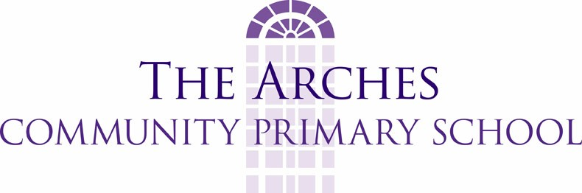

Remote Education Policy
Named contact for Remote Learning: Mrs Rebecca Challinor
Overview
Within its available resources during the National Lockdown, this school will do its best to provide a high quality of remote teaching and learning for all those pupils who need to be educated at home. However depending on circumstances during the epidemic we may have to modify this policy if the school sustains high levels of staff absence. As the pandemic develops, we may also have to modify our provision for remote learning by taking account of teachers’ workload in relation to the balance of pupils being taught in person on site and those being provided for remotely off site.
Intent
- We will publish information for pupils, parents and carers about their remote education provision on the website by 25 January 2021
- This school will make its best endeavours to use remote education to provide and teach a planned and well-sequenced curriculum to those pupils who need to be educated at home.
- We will ensure that the DfE guidance for safe remote learning and safeguarding underpin this policy.
- The teaching provided through remote learning will ensure that knowledge, skills and understanding are built incrementally so that pupils can make good progress through the school’s curriculum.
- This school will do all that it can within its resources to overcome any barriers to digital access for pupils.
- We will provide appropriate resources to structure learning, which will be supplemented with other forms of communication to keep pupils on track and to assess their progress.
- The school will do its best to put in place systems for checking regularly whether pupils are engaging with their work and making progress. We will offer support and advice where engagement is a concern.
- Teachers will set meaningful and ambitious work each day in an appropriate range of subjects
- Within our resources we will do our best to provide a minimum of 3 hours a day on average across the cohort in KS1, with less for younger children and 4 hours a day in Key Stage 2.
- The school will use its best endeavours to secure the educational provision called for by pupils’ special educational needs and vulnerable pupils.
Implementation
- A designated senior leader will be given overarching responsibility for the quality and delivery of remote education, including that provision meets the DfE expectations for remote education (published Jan 2021)
- The school will use a safe digital platform for remote education provision across the school and staff will be trained and confident in its use.
- Remote learning will include both recorded or live direct teaching time and time for pupils to complete tasks and assignments independently,
- Remote learning will set expectations that are appropriate to the pupils’ age, stage of development or special educational needs
- Remote learning will provide opportunities for interactivity, including questioning, eliciting and reflective discussion
- Pupils will receive timely and frequent feedback on how to progress, using digitally-facilitated or whole-class feedback where appropriate
- The school will work collaboratively with families, putting in place reasonable adjustments as necessary, so that pupils with SEND can successfully access remote education alongside their peers.
- Where individuals who are self-isolating are within the DfE definition of vulnerable, the school will use its reasonable best endeavours to put systems in place to keep in contact with them.
- When a vulnerable child is asked to self-isolate, the school will notify their social worker (if they have one) and school leaders will agree with the social worker, reasonable and practical ways to maintain contact and offer support to the vulnerable child or young person.
- The school will put in place reasonable, practical procedures to regularly check if a vulnerable child is able to access remote education support and to support them to access it as far as possible)
Impact
All pupils who need to be educated at home will be provided with and taught a planned and well-sequenced curriculum. Remote teaching will ensure that knowledge, skills and understanding are taught incrementally so that pupils can make good progress through the school’s curriculum. The senior leadership team and governors will keep the policy and provision for Remote Education under regular review.

