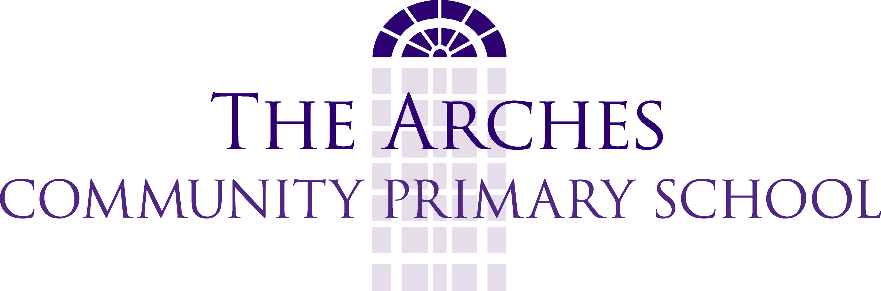

French Policy

At The Arches we believe that introducing a language at a young age has numerous benefits ranging from improving literacy skills through to developing self esteem and raising cultural awareness.

Continuity and Progression KS2
The attainment targets are split into four levels of ability in four strands.
- speaking
- listening
- reading
- writing

The curriculum is based on The Language Angels scheme and will be the primary means of delivery of MFL at The Arches. It is recommended as the medium term plan.

In KS2, Y3 pupils will work towards Language Angels Early language teaching, units 1 – 3 while Y4 will work towards units 3-6 and Y5 will work towards units 7- to intermediate language.

A multi-sensory and kinaesthetic approach to teaching is used, ie. a physical element is introduced into some of the games, rhymes and songs as this serves to reinforce memory.

Key Stage 1 and Foundation Stage 2
Although KS1 and FS2 will not be learning French formally, teachers are encouraged to use French incidentally through topic work where possible to encourage self esteem and confidence and make use of the ICT resources (tout-le-monde, Espresso, the internet) and games and books available.

Cross curricular links and Time Allocation
Teachers are encouraged to make cross-curricular links to embed French in the curriculum; the school has chosen to draw links with France through its use of the International Primary Curriculum. French is taught for 30 minutes per week to all Key Stage 2 classes, in line with Government expectations.

Staff Training
The subject leader will attend training and support meetings to keep abreast of current developments and report back to staff as required.

