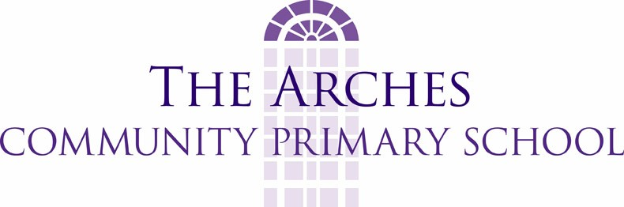

Policy for PE and school sport

Physical Education:
- educates young people in, and through, the use and knowledge of the body and its movement.
- can develop the skills and competence required to participate in worthwhile physical activities.
- promotes growth and physical development establishing positive attitudes towards health and exercise.
- develops an artistic and aesthetic understanding.
- helps establish self-esteem through the development of physical confidence, and helps children cope with success, and failure, in competitive and cooperative situations.

It is acknowledged that Physical Education is uniquely concerned with the physical area of experience. As it is essentially a way of learning through action, awareness and observations, its contribution to a child’s overall education which is of great importance.

School aims (incorporating the 10 indicators of excellence in PE and sport)
1. To promote a commitment towards Physical Education and sport, enjoying them, making them part of their lives, both in and out of school, and in later life.
2. To develop understanding in all areas of Physical Education including composition, choreography, strategy, tactics and problem solving.
3. To promote Physical Education and sport as part of a healthy and active lifestyle.
4. To develop confidence in Physical Education and sport, in a range of non-competitive, competitive, creative and challenge type activities, both individually and as part of a group.
5. To improve the skills and control needed to take part, and be able to apply and adapt these skills and techniques effectively.
6. To encourage children to think about what they are doing and make decisions for themselves, so they can organise, react to situations, and develop a desire to improve.
7. To develop the stamina, suppleness and strength to keep going in PE and sport and avoid injury.
8. To learn an understanding of rules, a sense of fair play and good sportsmanship.
9. To promote an awareness of safety in PE and sport, through good behaviour and safe practice.
10. To cater for individual needs and promote equal opportunities.

The Physical Education curriculum
In the foundation stage the pupils’ physical development covers a wide range of skills; the following are areas in which Physical Education can target specific skills, and develop them through the foundation stage, leading towards achievement of the Early Learning Goals.
- Movement: development of fine and gross motor skills
- Sense of space
- Use of equipment: being able to use a range of equipment
The following are areas in which Physical Education can assist in the development of specific skills –
- Health and bodily awareness
- Using tools and materials
Children will be taught Games, Gymnastic Activities and or Dance at Key Stage 1; at Key Stage 2 these will still be taught in addition to Athletic Activities, Outdoor Activities and Swimming.
Within each of these Activity Areas there are a variety of techniques, skills and movement patterns; these are taught initially at a simple level and are the foundations on which the more difficult skills and concepts are built. The acquisition, or learning, of these basics will ensure a smooth, enjoyable progression through each Activity Area.

Teaching the Physical Education Curriculum
Since children learn and develop in different ways and at different rates, teachers acknowledge that the teaching of Physical Education should be through a variety of teaching styles. The objectives of each lesson will take this into account. These are the types of teaching that could be used:-
- Observe a movement, practise it repeatedly with correction, guidance and attention to technical detail as required.
- Open ended tasks where pupils work to their own limitations and capacity.
- Teach common techniques to the whole class.
- Encourage children to ‘solve a problem’.
- Use demonstrations of own or pupils’ work as a stimulus.
- Individual, pair and group evaluation of performance.
The school uses part of its sports funding to employ specialist sports teachers to support and enhance teaching and learning.

Planning
Progression is ensured by a long-term plan for Physical Education. PE Passport is used to generate medium-term and weekly plans. Weekly plans may be flexible and PE Passport can be adapted as necessary to suit the needs of all learners.

Differentiation
In planning Physical Education the teacher will base their differentiation on thinking what all children MUST be able to do, what most children SHOULD be able to do, and what some children COULD do. Differentiation is the way the teacher achieves these objectives. Different methods of differentiation that could be used are:
- By Resource. Adapt the resources being used e.g. bigger, smaller, longer, shorter, or change equipment. Vary the number of players in a space or in a game. Change the size or distance of a target.
- By Task. Identify the outcomes specific to each pupil, or group of pupils. Set these outcomes to suit the ability of the pupils or group.
- By Support. The amount of help each child needs. Help can be provided from the teacher, teaching assistant, partner, peer group, or team.
- By Response. When a task is set, the outcomes for each child will vary. The teacher’s response will reflect what the student has achieved.

Assessment
All assessment is carried out as part of normal teaching; it is contained within the planning, as there are clearly stated learning objectives. The school uses PE Passport to facilitate this. Assessment is carried out by the teacher observing individuals, groups or the class, and seeing whether they are performing the techniques being taught at a relevant level. Knowledge and understanding of these techniques will then be checked by the teacher observing, questioning and listening. Assessment will link experiences to future learning.

Equal opportunities
All children, regardless of gender, race or ability, will be given equal opportunities to develop to the best of their ability in Physical Education.

Special Educational Needs
Planning and delivery of Physical Education will be based on a child’s ability and needs and differentiated accordingly.

Reviewing Physical Education
The process of teaching Physical Education is subject to regular review within the school. Teachers plan, teach, assess and make any necessary changes to their planning. This cyclic approach ensures that the teacher is constantly evaluating their teaching in order to best teach a broad, balanced Physical Education curriculum. The policy and schemes of work are also subject to review, in order to keep up to date with changes to the curriculum and modern practices.

Every Child Matters
The Every Child Matters agenda is fully incorporated in the teaching of Physical Education. It is especially relevant in the first four strands.
- Being Healthy
- Staying Safe
- Enjoying and achieving
- Making a positive contribution
- Achieving economic well being.

General Safety Rules for Physical Education
- All children need a change of clothing and footwear suitable for the activity being undertaken.
- For dance and gymnastics, children should wear flat-soled plimsolls to give greater control.
- The teacher should be in PE kit and appropriate footwear to set an example to the children.
- No jewellery, watches or bracelets should be worn for any PE lesson. (Includes studs)
- The children should be aware of the code of conduct in PE lessons, and maintain a high standard of behaviour.
- Equipment and apparatus should be carried correctly. Children need to be shown how to do this.
- For swimming, children need their own towel and correct swimwear. They will need parental consent if they want to wear goggles.
- They should be aware of emergency procedures for swimming and other lessons.
- Children needing inhalers, and other medication, should carry them to all PE lessons.

