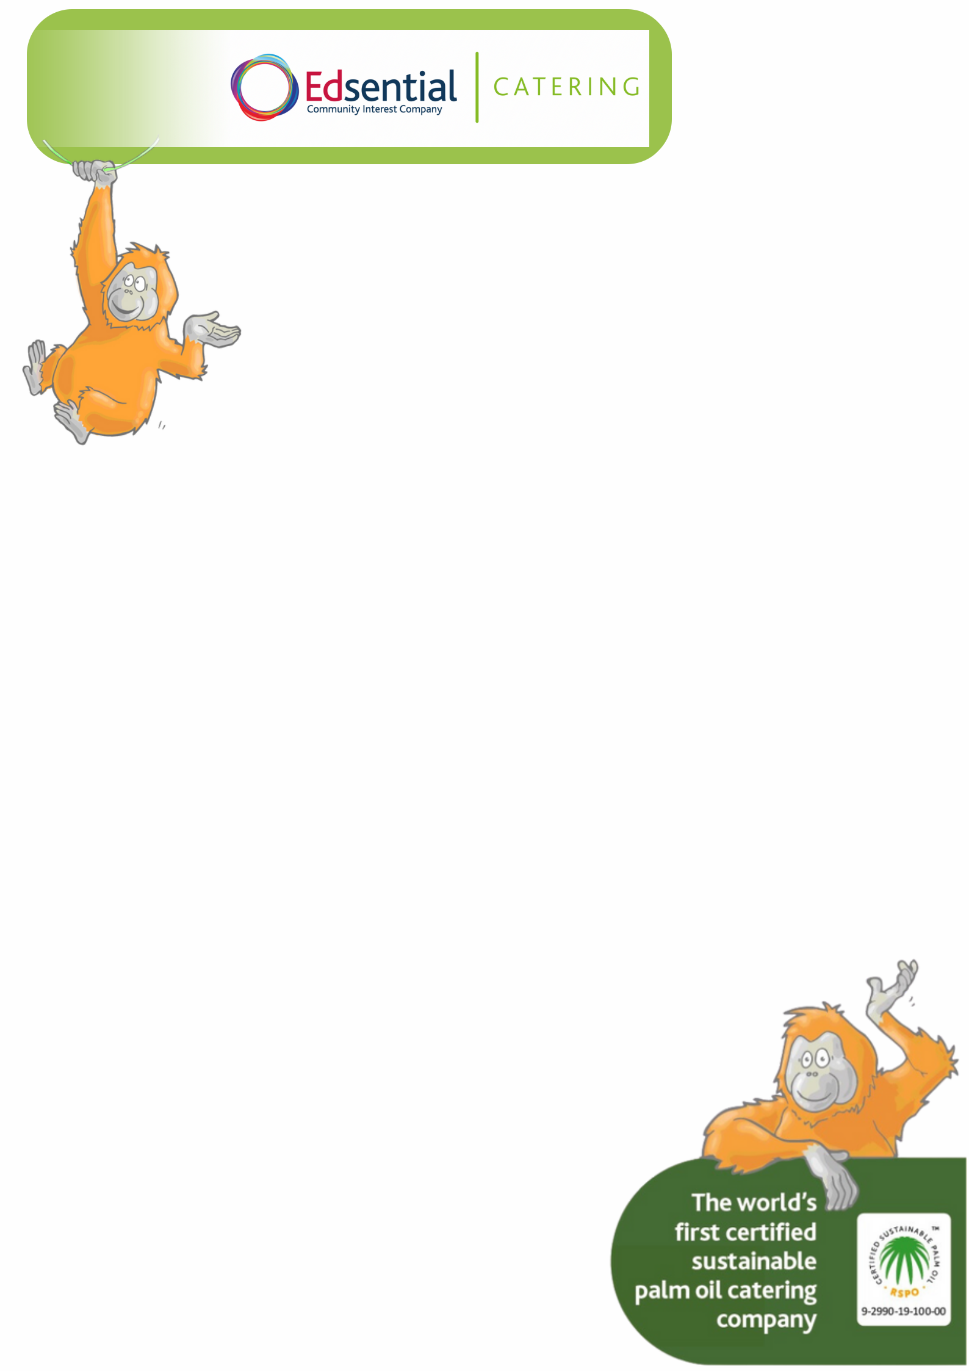

Morning Break

September Price List 2024

Slice of Toast................................. | 25p
Piece of Fruit.................................... | 35p
Carton of Milk 200ml................... | 45p
Milkshake 200ml........................... | 50p
Apple Juice………………….......... | 50p
Orange Juice............................... | 50p
Half a Bacon Sandwich................. | £1.00

