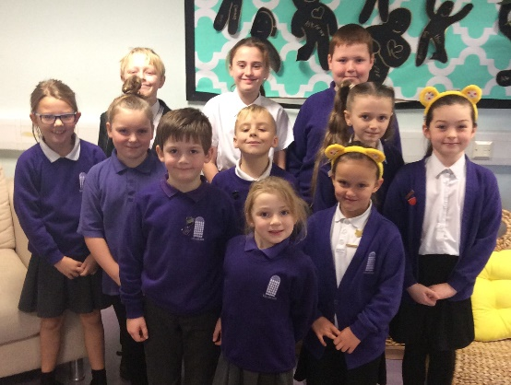

What is so good about gaming?

Games are enjoyable because they are satisfying. Children play games because you can talk to your friends and play online. You can play as many games as you like and on games you can share ideas and tips with your friends. Games are also a good way to entertain yourself online.

Mollie

Roblox

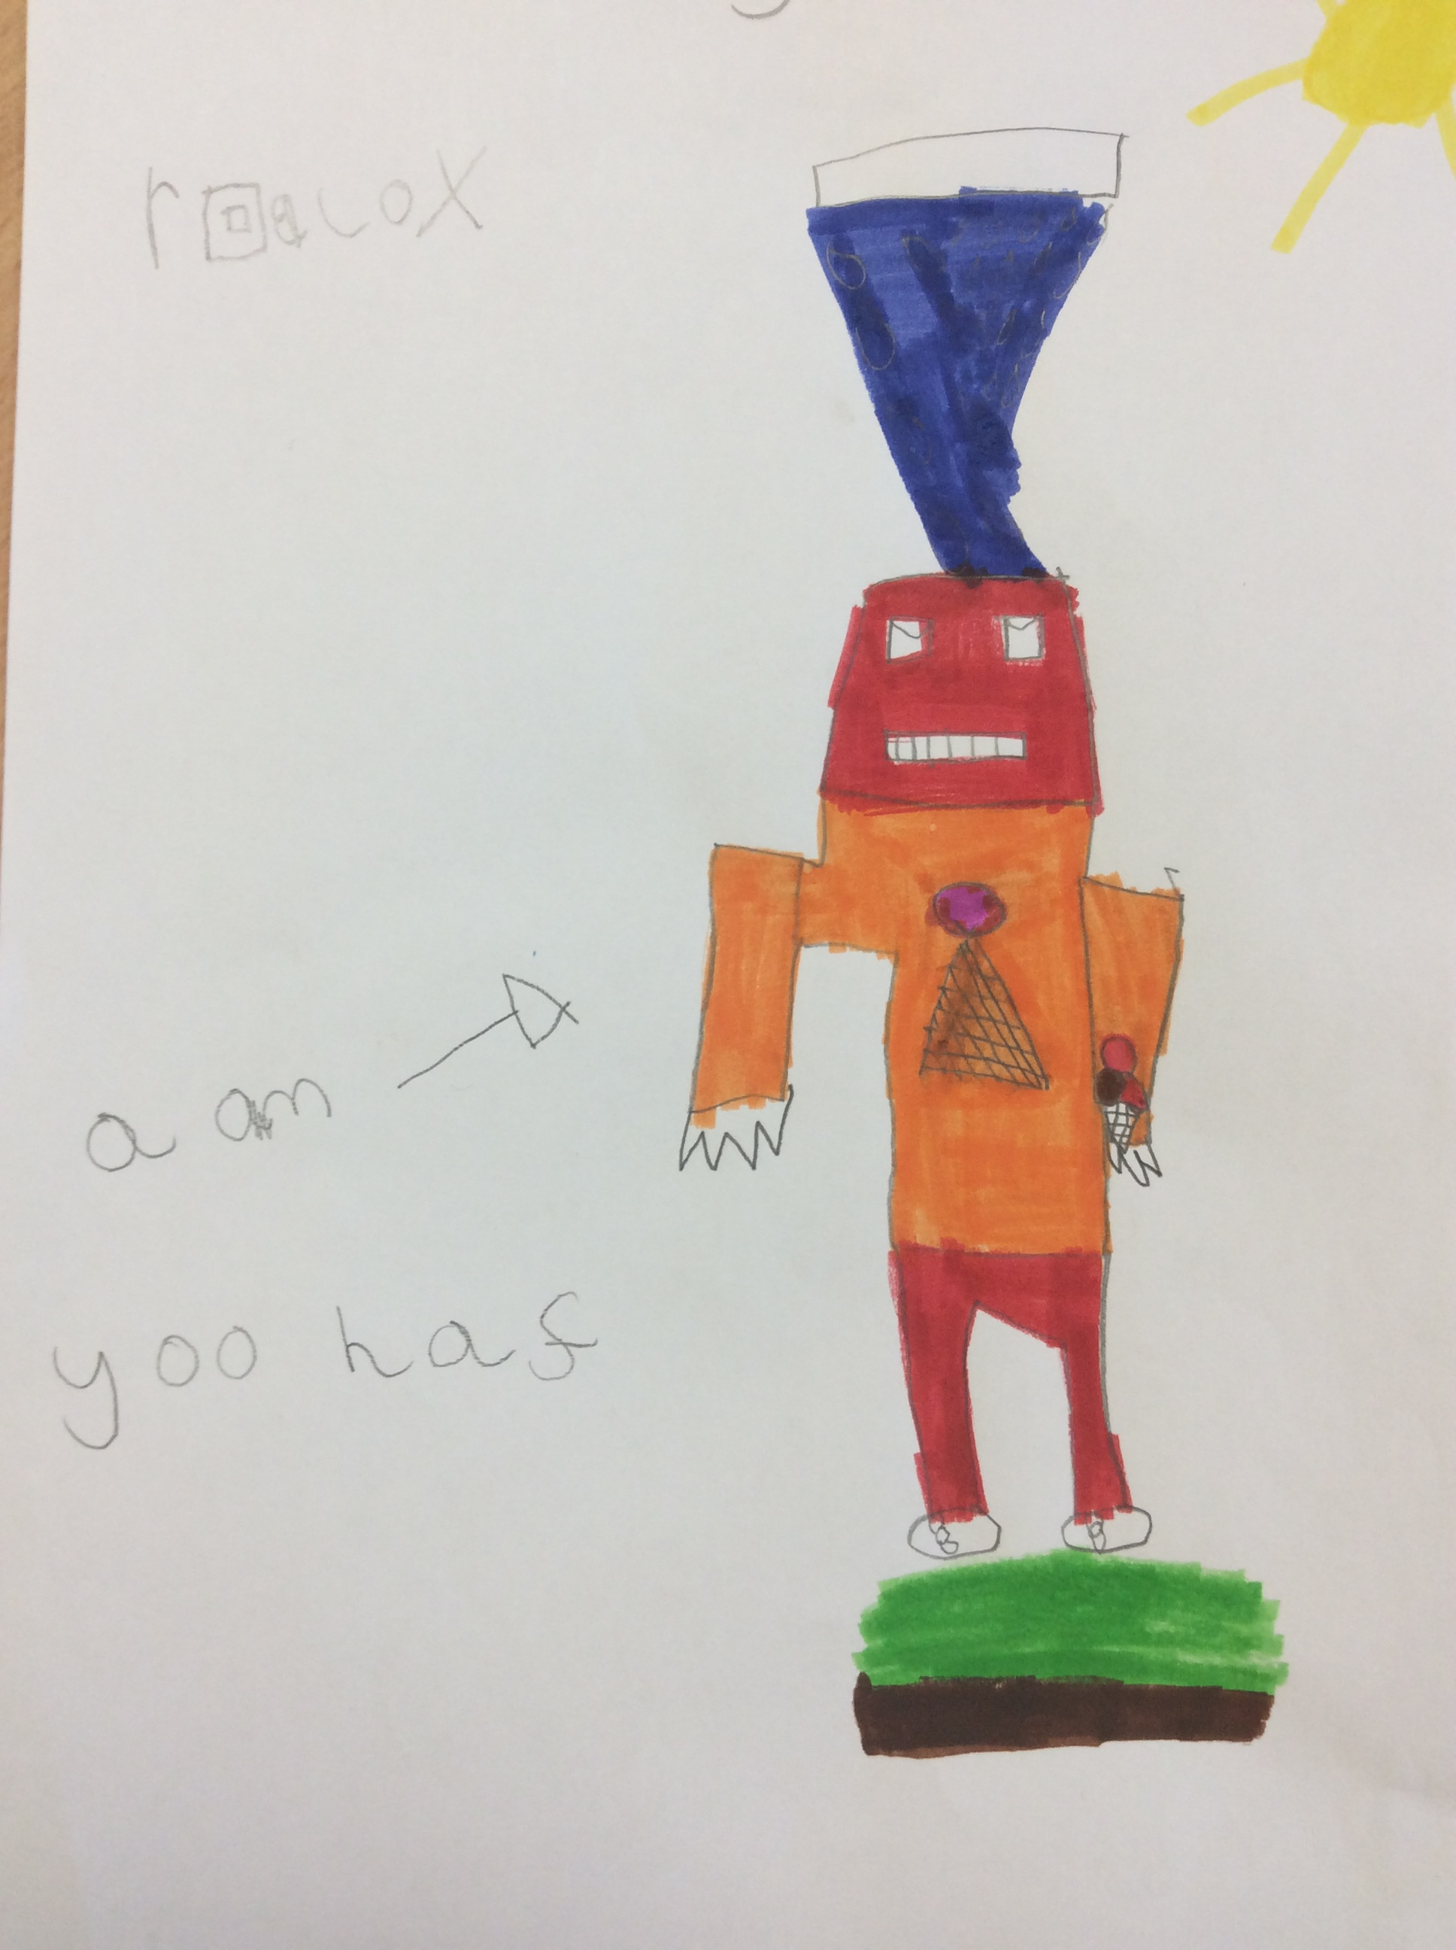

Becky – My favourite game.

My Favourite Game

Run Sausage Run! Is a good game because you’re a little sausage running around the house. There are lots of things to stop you. You have to try to get out of the house but Run Sausage Run never ends. I love this game because it’s funny. It is officially rated PEGI 7.

Blake

My Baby Unicorn

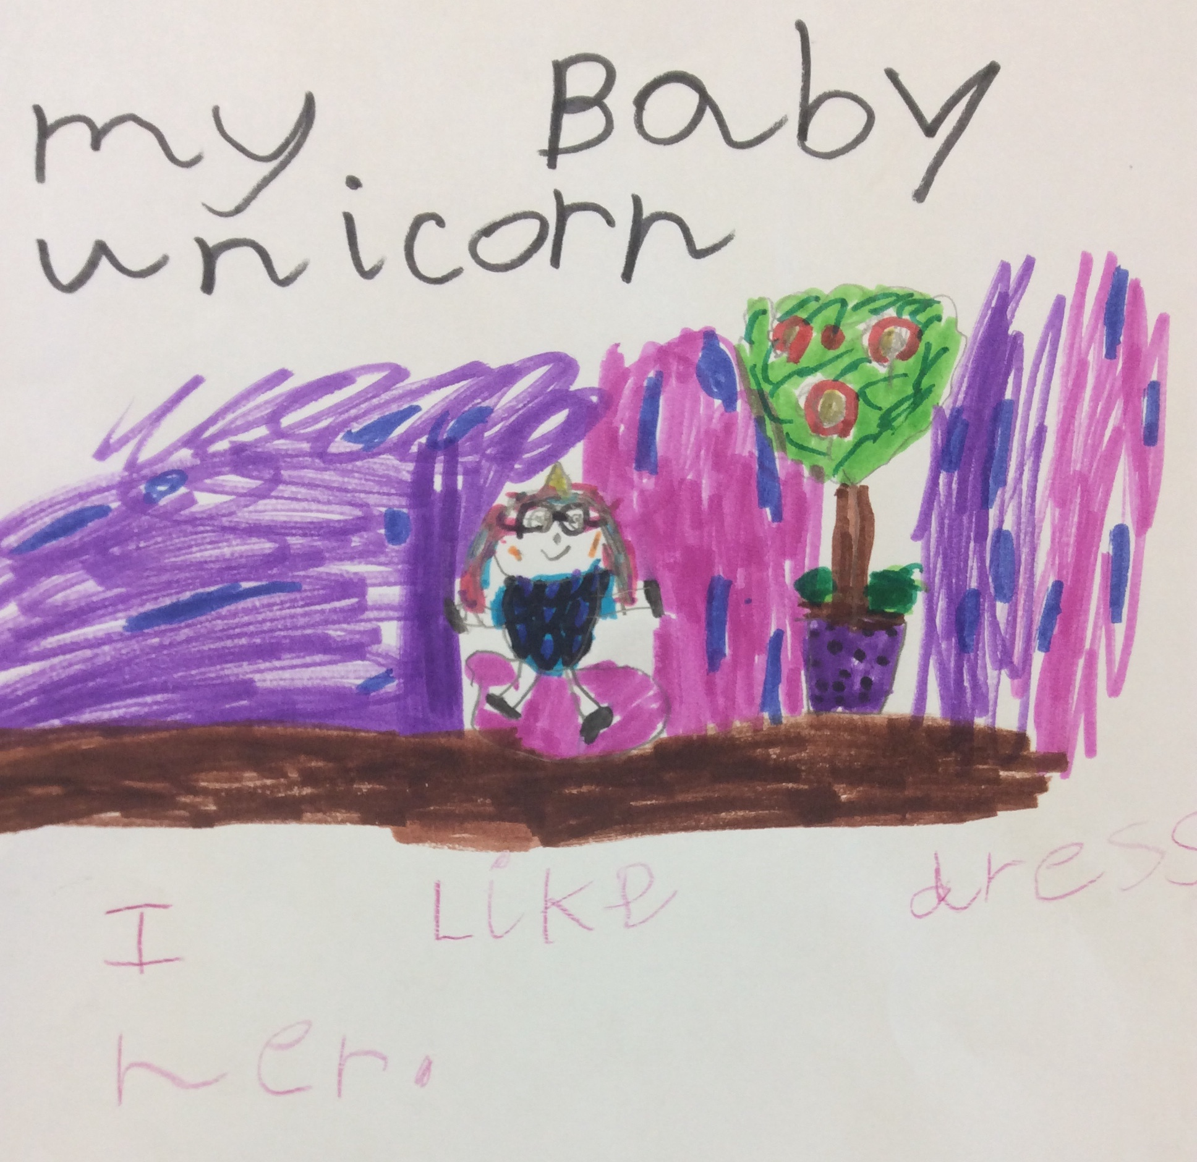

Maja – My favourite game.

Finn

Good Games for FS2

All of these games are rated 4+ or PEGI 3 on App Store and Google Play:

* BBC CBeebies Storytime;
* World of Peppa Pig;
* Fruit Ninja;
* My Talking Tom 2;
* Sand Balls;
* Colour Fill;
* Pou;
* Slither iO

There are lots more too!

Jaime

**GAMING SPECIAL!**

NEWSLETTER 3 (Feb 2020)

Spending Too Long Online

Even though video games are fun challenges we have to put limits on how long we play. Games like Fortnite, Minecraft etc can be addictive, but playing too long can cause problems. It can cause headaches, dizziness and vomiting and can also cause anger and sleepiness if playing at night. When you don’t do anything else, you don’t get enough exercise. I think an appropriate limit is about an hour.

Jack

Good Games for Key Stage 2

These games and Apps are rated 3+ on Google Play:

* Scratch Jr;
* Mario Kart;
* Sand Balls;
* Subway Surfers;
* Wallace & Gromit’s Grand Adventures;
* Colour Fill 3D;
* Bouncing Balls.

Sophia

Why should we care about age ratings?

The people who created the PEGI system analyse games’ content to check which age limit is right for the game. On the packaging it will say 3, 7, 12, 16 or 18. These mean if you are older than the age on the packaging you should be allowed to play that game. PEGI stands for Pan European Game Information.

Archie

Good Games for Key Stage 1

Lots of Key Stage 1 children enjoy playing Fortnite, but did you know it’s rated 12? These games and apps are suitable for Key Stage 1 children:

* Hill Climb Racing 2;
* Kodable;
* Nickelodeon Kart Racers;
* Lego Jurassic World;
* Lego Ninjago Movie;
* Sonic Forces: Standard Edition;
* Supermario Party;

Alicia

Trolling on Games

A troll is someone who deliberately stirs up drama in a game to cause hassles for other players. Trolling is very mean to people and can cause crying and mental breakdown. You can be arrested for trolling. If you are trolled you should block the person and report them, then tell an adult you trust.

Isobel

Minecraft

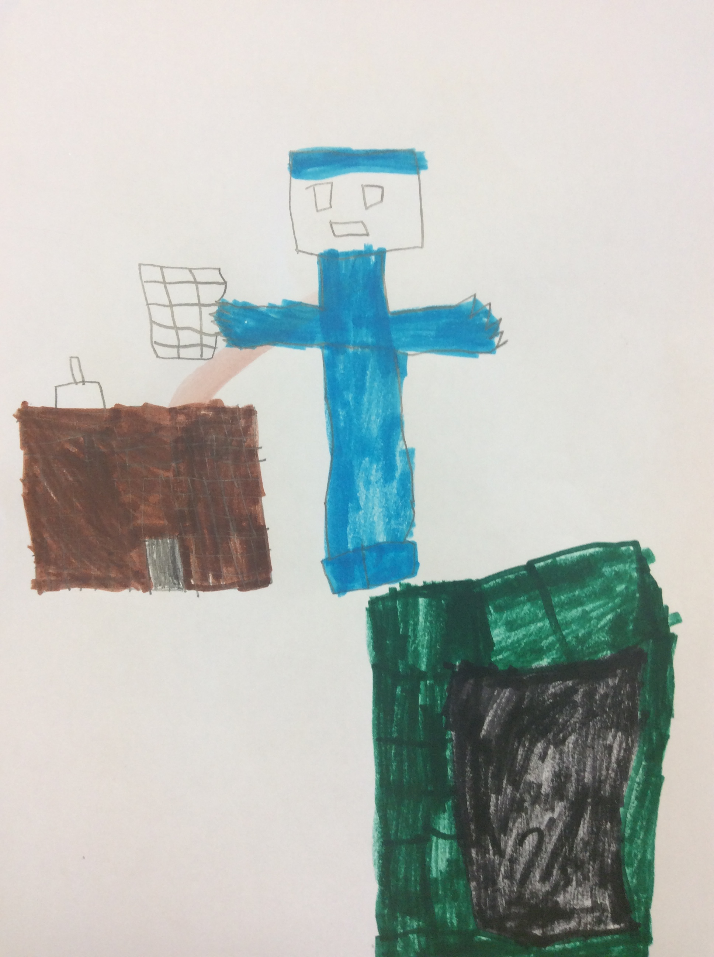

Finn – My favourite game.