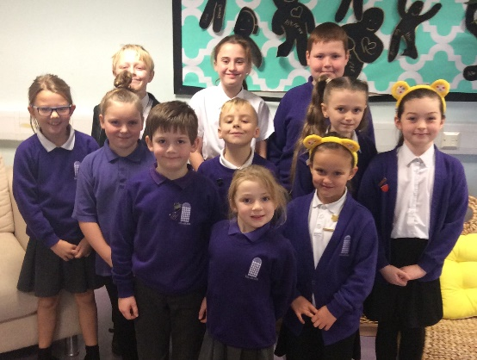

Unspeakable

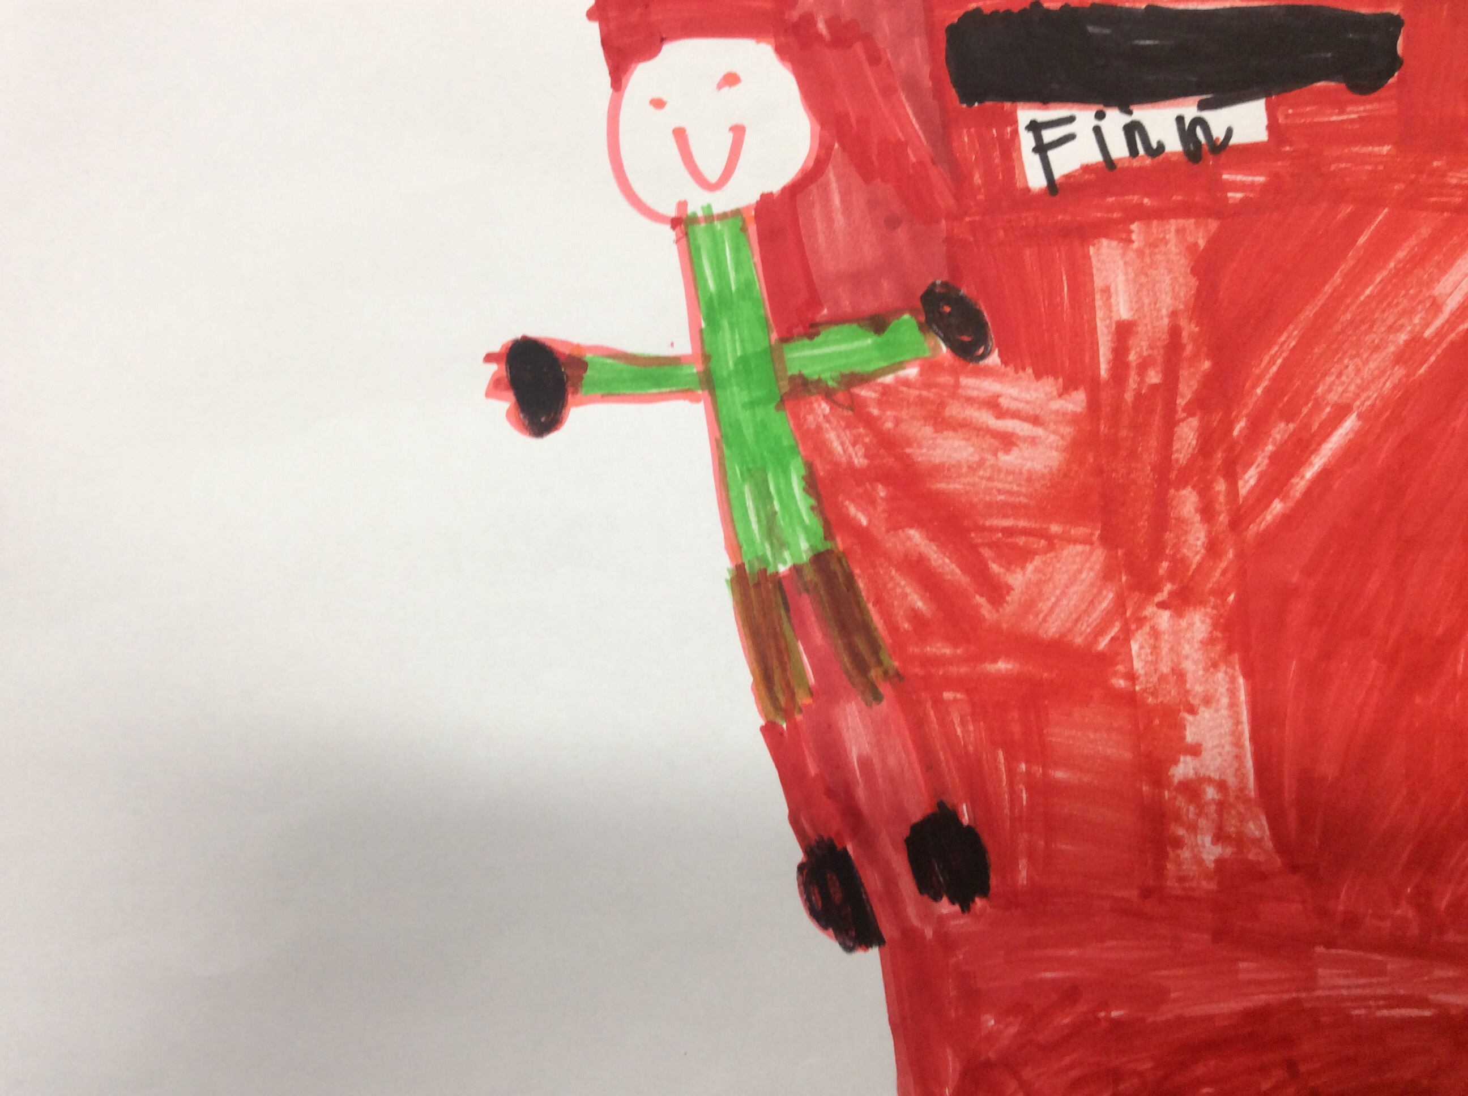

Finn

Finn

My favourite YouTuber – Carter Sharer

Carter Sharer was born on October 23rd 1993 and is 26 years old. He lives in a mansion in California. His videos show him doing lots of challenges. His girlfriend is Lizzy. Carter has two siblings – a brother and a sister. I like watching his YouTube channel because he gives money away and because he does fun challenges. He does lots of jumping challenges and flips on the trampoline.

Blake

He does fun challenges. They’re really funny.

**They’re funny. They gone to meet the Queen**

Minions

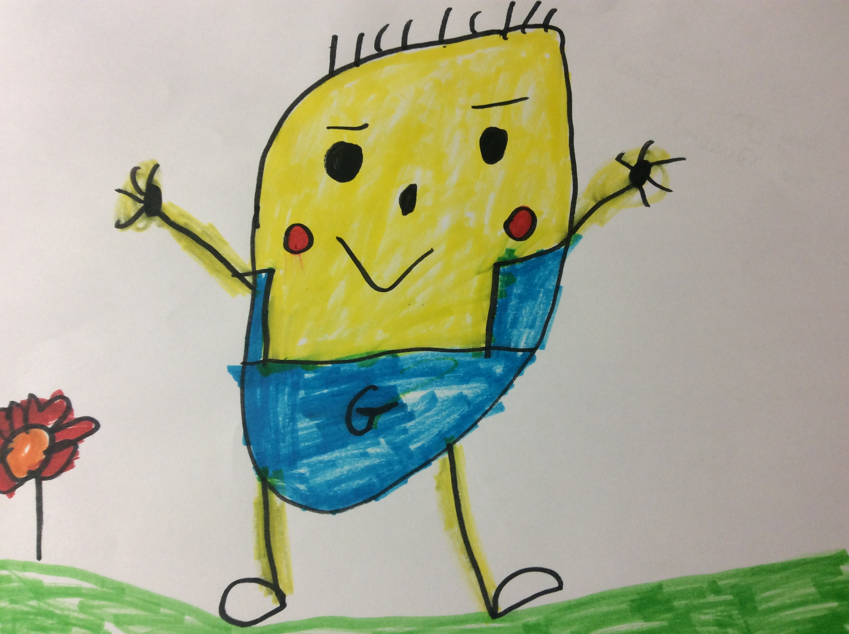

Maja

What’s so good about YouTube?

YouTube is a good place to learn things and get creative, like how to make slime. It’s a great way to get educated! You can learn recipes and watch music videos. I like to watch funny videos that make me laugh, like Micky Mouse Flushed Away. The best thing about YouTube is that you can have fun.

Alicia

Welcome!

Welcome to our second newsletter and welcome to our newest eSafety Champions – Becky, Maja, Alicia and Jack. The Champions have decided they would like to dedicate this newsletter to YouTube – the most popular website with our pupils. They have researched and written this newsletter themselves. I am so proud of their work!

Mrs Johnson

**SPECIAL!**

NEWSLETTER 2 (Dec 2019)

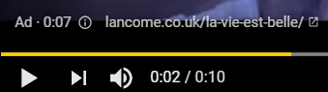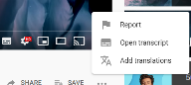

Once their pool went crazy and I laughed my head off.

What could go wrong?

We love lots of YouTubers and want to find their videos. Sometimes other people use YouTubers’ names to post scary videos. Make sure it’s the right YouTuber account before you press play. If you see something you don’t like **tell a trusted adult straight away**.

Adverts and Auto Play can also be a problem. Some of the adverts are not for children. To report an advert, click on the i, then ‘stop seeing this ad’. You can then report the advert to YouTube.

AutoPlay will automatically play another video. These are not always appropriate. To stop a video quickly, click on the 3 lines in the top left corner, then HOME. To turn off AutoPlay click on the settings cog then turn off Auto Play.

Jaime and Sophia

Trinity Beyond

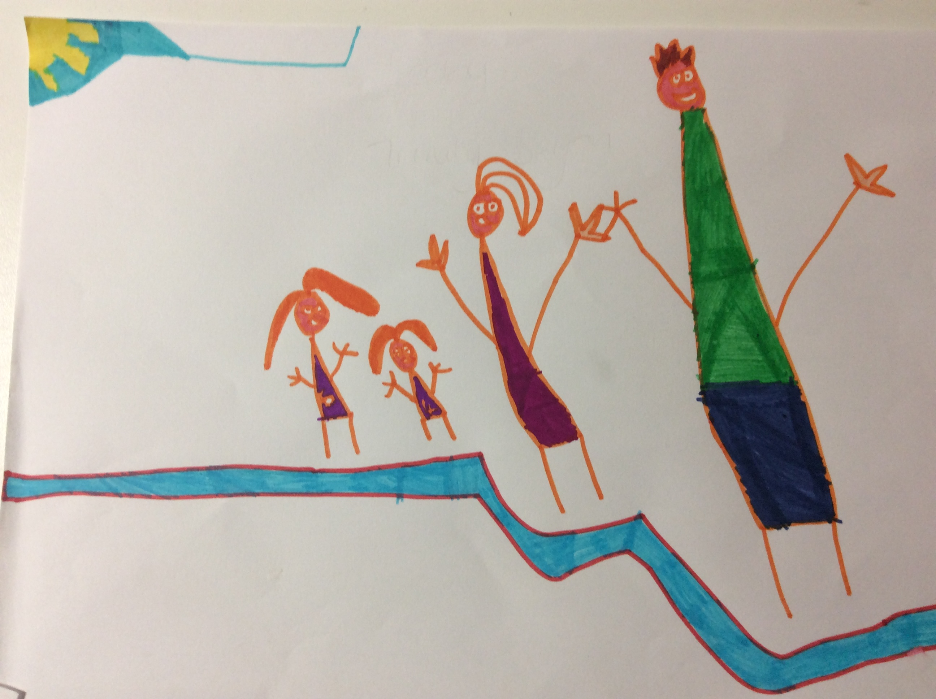

Becky

What to do if you see something you don’t like

**You should always remember that you are in control.**

If something pops up that you don’t like, don’t click on it and go off the app. If you get sent something you don’t like, block or report them. Don’t ever pass it on. Most images that are scary are not real, they are just made to look real. To make sure you don’t receive upsetting, check your privacy settings and make sure they are switched on. Never share your personal information online.

**If you are ever scared or upset by something you see online TELL AN ADULT!**

Archie and Mollie

How to report a video

YouTube is a good place to find things out, entertain and socialise but things can be scary, dangerous or not suitable for children our age. If you see a video that upsets or scares you, you can report it by clicking on the 3 dots just under the video, then the report flag.

On a phone or tablet, tap MORE at the top of the video, then tap REPORT.

Jack and Isobel