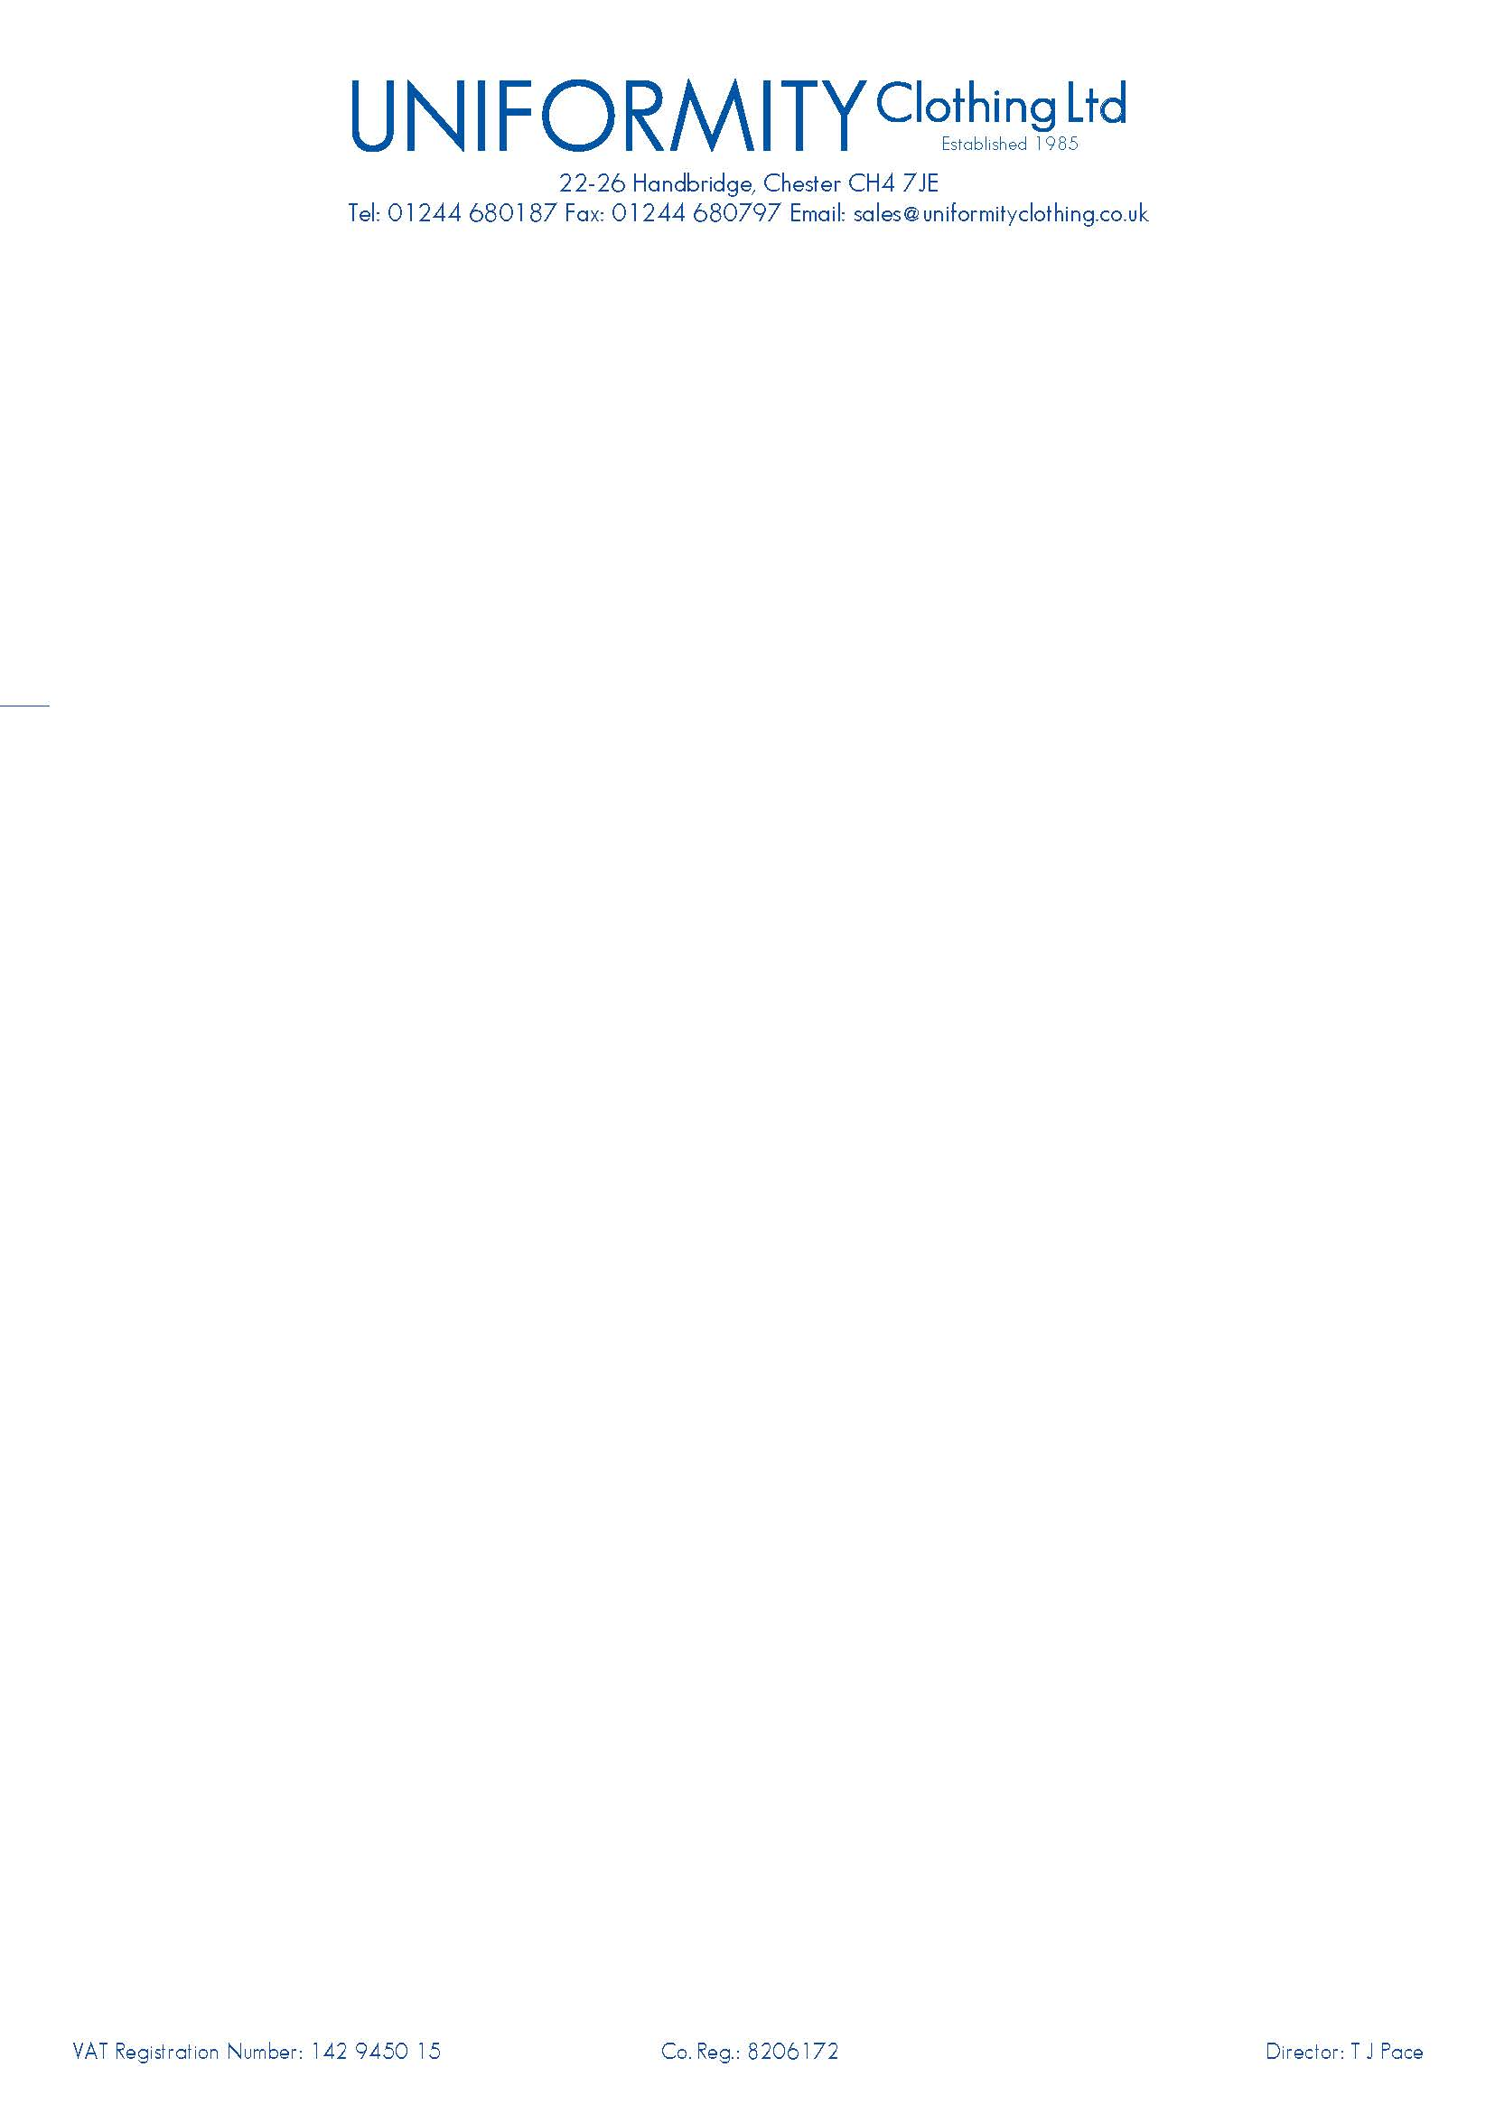

Dear Parent

Uniformity Clothing Ltd are pleased to introduce ourselves as your school uniform supplier.

You can purchase your uniform from our shop:

**22 – 26 Handbridge, Chester, CH4 7JE**

The uniform will be stocked here all year round and will be embroidered and ready for you to take away as and when you call. Our opening times are:

Monday to Thursday – **8.30am** to **5pm**

Friday – **8.30am** to **4.30pm**

Saturday – **9am** to **4pm** on 5th / 12th / 19th & 26th August and 2nd & 9th September 2017 only.

Should you find that you are unable to make these opening times, you can order on line with our free delivery to school during term time, within 2 working days. All uniform stock will be available from mid-June. To ensure you have your child’s/children’s uniform ready for the first day back we advise that you visit or order your uniform before 18th August 2017.

Our website can be found at www.uniformityschools.com

For a small charge we can deliver direct to your home.

Our contact details are:

Phone: 01244 566486

Email: [info@uniformityclothing.co.uk](mailto:info@uniformityclothing.co.uk)

Fax: 01244 680797

We look forward to seeing you soon.

Terry Pace

Managing Director

Uniformity Clothing Ltd