 | Autumn 1 | Autumn 2 | Spring 1 | Spring 2 | Summer 1 | Summer 2
Year 1/ Year 2  Rolling Programme  Year A  Autumn Year 1/2 | SEASONS AND WEATHER | GUY FAWKES | OUR COUNTRY! | LONDON | QUEEN VICTORIA | TERRIFIC TOYS!
 | 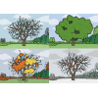 |  | 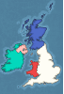 |  | 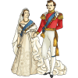 | 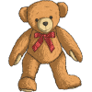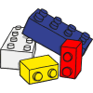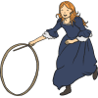
Year 1/ Year 2  Rolling Programme  Year B  Autumn Year 1/2 | CONTINENTS AND OCEANS | ROBERT FALCON SCOTT | THE GREAT FIRE OF LONDON | MAPPING! | AFRICA | MANDELA
 |  |  | 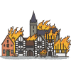 | 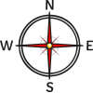
Year 3 | STONE AGE, IRON AGE AND BRONZE AGE |  | BRITAIN |  | VOLCANOES AND EARTHQUAKES
 | 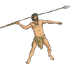 |  | 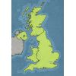 |  | 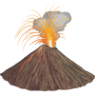
Year 4 | ROMANS |  | THE AMAZON |  | MAYANS
 |  |  | 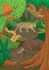 |  | 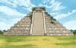
Year 5  Rolling Programme Autumn Term  Year 5/6 | ANCIENT GREEKS |  | WATER |  | TUDORS
 |  |  | 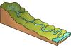
Year 6  Rolling Programme Autumn Term  Year 5/6 | ANCIENT GREEKS |  | VICTORIANS |  | WORLD WAR 2
 |  |  | 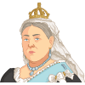 |  | 